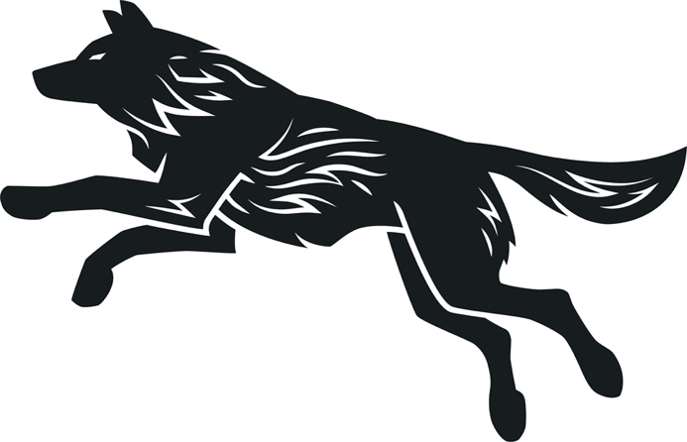

The Winery at Wolf Creek

BOURBONS 2 oz 3 oz

Angel’s Envy $11 $14
Basil Hayden $11 $14
Blade & Bow $13 $16
Buffalo Trace $10 $13
Bulleit $10 $13
Elijah Craig $10 $13
Maker’s Mark 46 $13 $16
Wolf Creek Distillery $12 $18

CANNED COCKTAILS

Captain Morgan’s Sliced Long Island $8
Southern Tier Bourbon Smash $9
Buzz Box Mojito $9

BEERS

Jackie O’s Mystic Mama $5
Fat Head’s Bumbleberry $5
Columbus IPA $5
Columbus Bodhi $5
Great Lakes Dortmunder $5
Garage Beer $4
Narragansett $4
New Belgium Fat Tire $5
Sam Adams Boston Lager $5

HEMP INFUSED THC DRINKS

Strawberry Provencal & Lemongrass $8
Peche & Wild Honeysuckle $8
Watermelon & Pink Peppercorn $8

